# Project Go Shopping! (GDD)

## Brief

* Top-down view (Stardew Valley style)
* It has two characters: player and shopkeeper
* Player walks and interact with the game world
* Player can talk to the shopkeeper
* Player can buy, sell and equip items
* Player’s equipped items should be visible
* Items have icons and price tag

## GDD

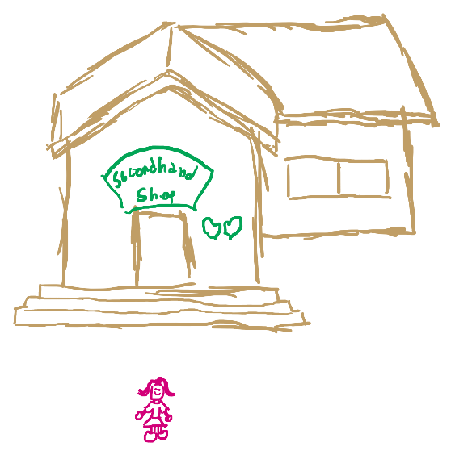

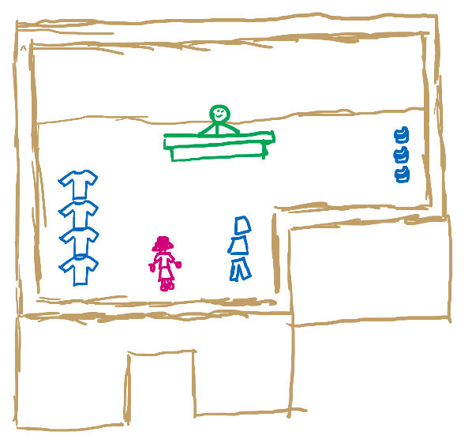

<IMAGE 1 – SHOP’S OUTSIDE> <IMAGE 2 – SHOP’S INSIDE>

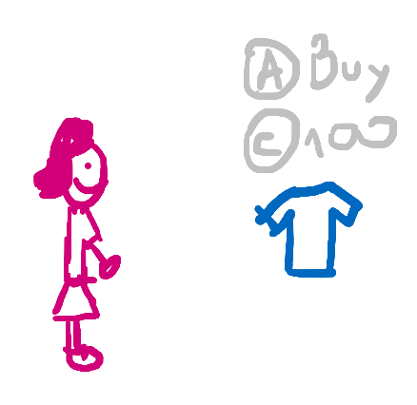

<IMAGE 3 – PLAYER FACING A PIECE OF CLOTH>

When the player is facing an item that is at most **2 units away** from him, he should see the item price tag and the buttom prompt to interact with it.

When in sop, the player should only need to face the item he wants to buy and click the buttom.

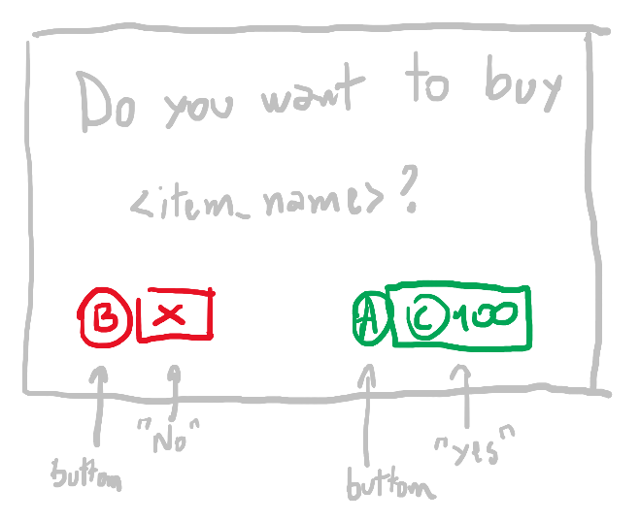

<IMAGE 4 – BUY WINDOW PROMPT>

When clicking to buy an item, the aboce windows appears at the screen’s center asking the player if he wants to buy the item.

If the pçayer wants, he can talk to the shopkeeper and instead buy from him using list. In this windows the player can sell items too.

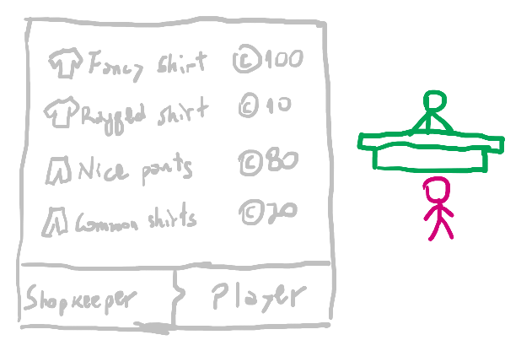

<IMAGE 5 – BUY/SELL SCREEN>

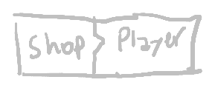

Shopkeeper is selling to the player

<IMAGE 5a – SHOP SELLING TO PLAYER>

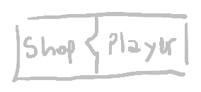

Player is selling to the shopkeeper

<IMAGE 5b – PLAYER SELLING TO SHOP>

While buying/selling, the player goes to the right of the screen and the buy/sell panel appears to the left. While on that window, if the player clicks his name, he’ll see his inventory to sell things. Clicking on the shopkeeper’s name will see his inventory to buy instead.

If the player clicks on himself or click **i** key, or clicks the backpack icon, he can see his own inventory. Now the camera makes the player go to the left of the screen and his inventory appearst the right.

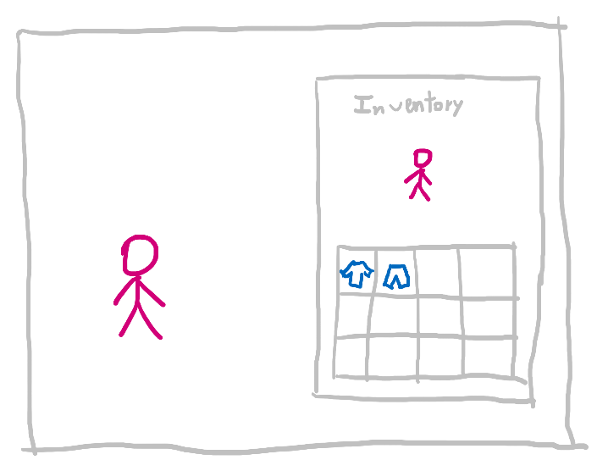

<IMAGE 6 – INVENTORY SCREEN>

If the player drag and drop an equipabble item to he’s character representation in the inventory window, he equips it.

If the player drags off an item from his body (that is represented in the inventory window), he unequips it.

The standard clother are underwear.

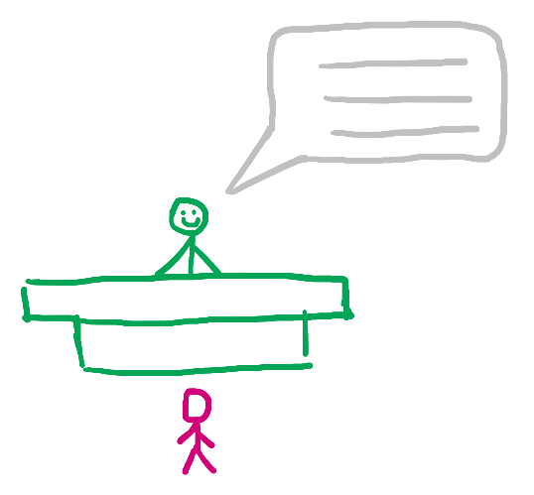

<IMAGE 7 – SHOPKEEPER’S DIALOG>

When entering the shop, a ring bell plays (*\*bling bling\**) and the shopkeeper tells:

*Shopkeeper:*

“Welcome to my shop! If you see something you want, just click and buy it.

<PAUSE>

Oh! I’m always wanting to replenish my stock, so if you have something to sell, just talk to me.”

At the start, the player already has in his inventory an old t-shirt, a ragged jeans and two pair of shoes. If he wants, he can sell them to the shopkeeper.

To sell something in the buy/sell window, just click onto a player’s item to sell.

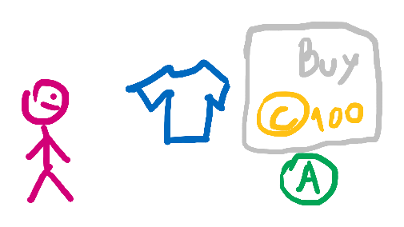

<IMAGE 8a – MOUSE OVER A PIECE OF CLOTH IN THE SHOP SHOWING THE “BUY” HINT>

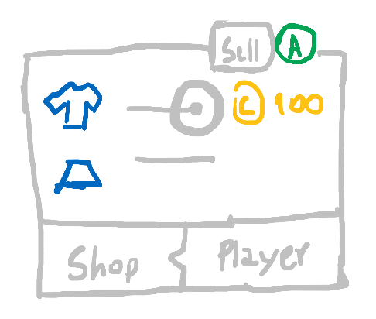

<IMAGE 8b – MOUSE OVER AN ITEM IN THE BUY/SELL WINDOW SHOWING THE “SELL” HINT>

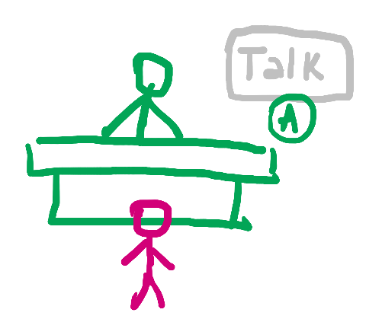

<IMAGE 8c – MOUSE OVER THE SHOPKEEPER SHOWING THE “TALK” HINT>

Mouse pointer will work like in Assassin’s Creed Origins, where the player moves the pointer to select UI elements.



<IMAGE 9 – MOUSE POINTER LIKE IN ASSASSIN’S CREED ORIGINS>

While hovering an interactable, a hint appears at the side of the mouse pointer telling the player what action will happen if he clicks on it.

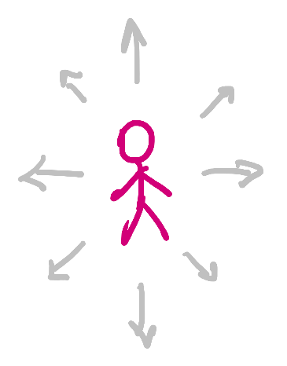

<IMAGE 10 – PLAYER MOVEMENT INDICATION>

The player can move using arrow keys or WASD.

## Features

* Walk
* Interaction
* Inventory
* Equipment
* Trade
* Talk bubble (for the shopkeeper speech)

## Visuals

* Stardew Valley (camera’s perspective)
* The Sims 4 (colors)
* EXTRA: Pixelated camera

## Assets

* 1 Player (3 angles)
  + Front
  + Back
  + Side
* 1 Shopkeeper (front)
* 1 Balcony (front)
* 4 t-shirts + 1 underwear (3 angles)
  + Front
  + Back
  + Side
* 3 pants/shirts/skirts + 1 underwear (3 angles)
  + Front
  + Back
  + Side
* 3 shoes + 1 feet (3 angles)
  + Front
  + Back
  + Side
* 1 rack (cabideiro/pendurador de roupas)
* 2 walls (front + back)
  + Shop’s outside
  + Shop’s inside
* 1 wall (side – just concrete, wood, etc.)
* 3 floor tiles
  + Outside grass
  + Outside dirt
  + Inside floor (shop)
* 1 ceilling (shop)
* EXTRA: 1 tree
* EXTRA: 2 hats (3 angles)
  + Front
  + Back
  + Side
* EXTRA: 1 coat (3 angles)
  + Front
  + Back
  + Side